1.
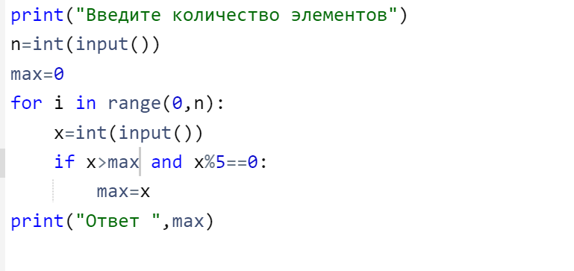
11.
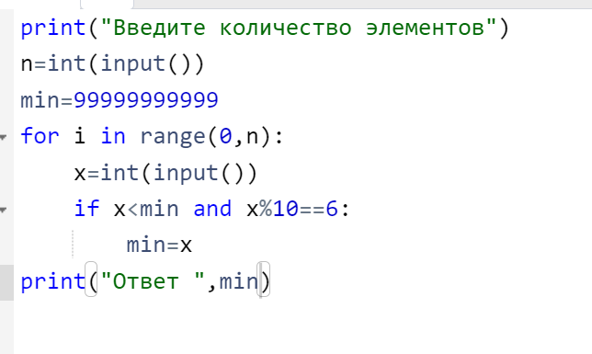
12.
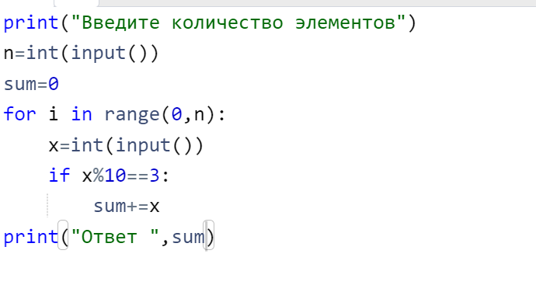
13/
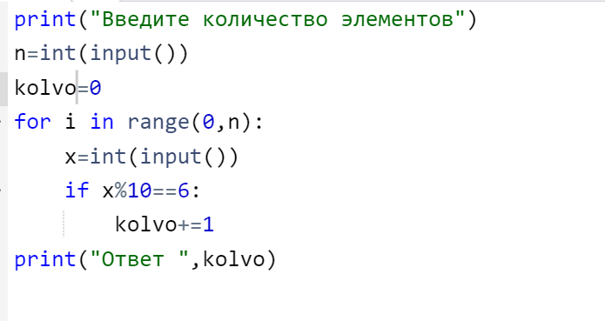

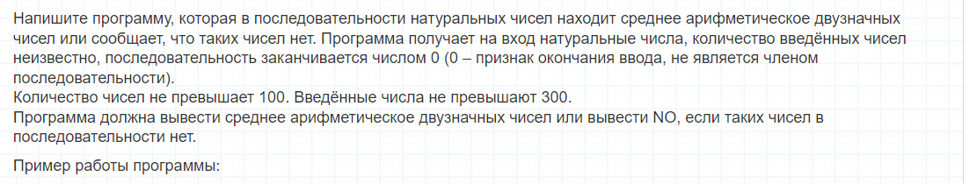

x=-93210974891268745127547391798340921798756891327091
n=0
sum=0
while x!=0:
x=int(input())
if x<=99 and x>=10:
sum+=x
n+=1

if n==0:
print("NO")
else:
shrek_Sredniy=sum/n
print(shrek_Sredniy)

